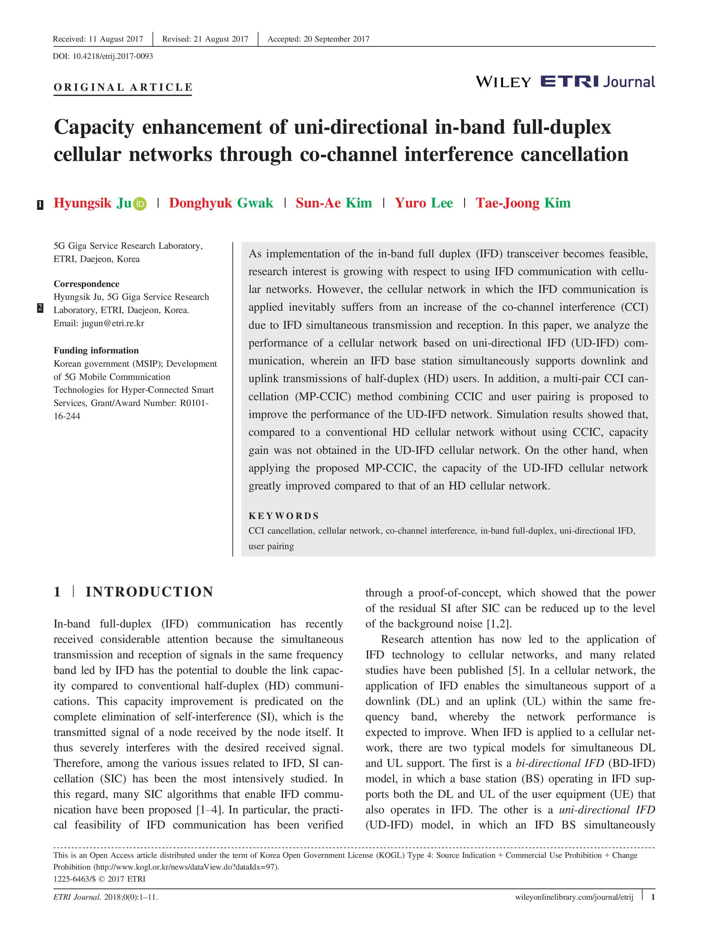
1 | INTRODUCTION
ARTICLE TYPE

Style Guide for ETRI Journal Authors
Author One*¹ | Author Two ^{1, 2} | Author Three²

¹ Org. Division, Org. Name, State name,
Country name.
² Org. Division, Org. Name, State name,
Country name.

Correspondence
*Corresponding author name, This is sample
corresponding address. Email:
authorone@gmail.com

Funding Information
This research was supported by the This is
sample for funding information text this is
sample for funding information text
This document must be read carefully by any author intending to submit material to ETRI Journal. The submitting author must follow all instructions stated herein. Any submission that fails to comply with the rules stated herein will not be considered for publication. As papers are double-blind peer reviewed, the main text file should not include any information that might identify the authors.
KEYWORDS
Example 1, example 2, example 3, etc.

Received: Date Month YearReceived: Date Month YearAccepted: Date Month YearDOI: 10.4218/etrij.0000-0000

This document is an ETRI Journal template for Microsoft Word. If you would prefer to use LaTeX, please download a template on ETRIJ website (http://wileyonlinelibrary.com/journal/etrij). The manuscript template is already correctly formatted in accordance with ETRIJ Author Guideline. Do not use any other template. Input the material as simply as possible and do not embed special formatting in the text, such as field codes.
2 | MANUSCRIPT PREARATION
2.1 | Length of manuscript
The length of an article is limited to between 8 and 10 pages in the two-column format of ETRI Journal, excluding author biographies. The article should concisely present the background of the topic, the purpose of the investigation, the details of the investigation, the results, and the conclusions. The font size, character scale, and character spacing should not be manipulated to fit the page limit.
This is an Open Access article distributed under the term of Korea Open Government License (KOGL) Type 4: Source Indication + Commercial Use Prohibition + Change
Prohibition (https://www.kogl.or.kr/info/license.do#05-tab).
1225-6463/$ © 2021 ETRI

2.2 | Abstract
Every published paper must contain an abstract. By nature, abstracts should not contain numbered mathematical equations or numbered references. The abstract should succinctly state the focus of the article, how the research is conducted, the principal results, and the significance of the results, in the present tense, not the past tense. The abstract should only contain the most critical information of the paper. The abstract of a regular paper or special issue paper is limited to 1200 characters, including spaces. The font size of the abstract should be 9.5 points.
2.3 | Consecutive numbering of parts
All manuscript pages, footnotes, equations, and references should be labeled in consecutive numerical order. Figures and tables should be cited in the text in numerical order.
2.4 | Sections
A regular or special issue paper generally consists of the title, author affiliation, funding information, abstract, introduction, body, conclusion, and reference list. A regular or special issue paper may also include appendices, a glossary of symbols, and an acknowledgment of non-financial support. The author name(s), author affiliation and funding information must not appear when submitting or during review to maintain anonymity between reviewers and authors.

1 | FIRST-LEVEL HEADING (12 pts)
2 | FIRST-LEVEL HEADING (12 pts)
3 | FIRST-LEVEL HEADING (12 pts)

1.1 | Second-level heading (12 pts)
1.2 | Second-level heading (12 pts)
1.3 | Second-level heading (12 pts)

1.1.1 | Third-level heading (12 pts)
1.1.2 | Third -level heading (12 pts)
1.1.3 | Third -level heading (12 pts)

Fourth level head text (10.5)
This is sample text.

Fitth level head text (10.5) This is sample text.

A period (.) must follow each identifier and each heading should be left-aligned on the page.

2.5 | Mathematical notation
ETRI Journal advocates two means by which to insert equations into your MS Word document — MS Word’s inbuilt equation editor or MathType.
MathType is much the preferred method over MS Word’s inbuilt equation editor. It is easier to alter the individual elements that make up an equation within MathType than it is within MS Word’s inbuilt equation editor. This is essential to those members of the editorial team who will be working on your paper.
2.5.1 | Numbering
Equations should be numbered consecutively using Arabic numerals enclosed in parentheses, as follows:
R = (a × b)/c, (1)
BAL_{TOTAL} = 2M + 9y – 3x. (2)
The equation number in parentheses should be flush with the right margin. The symbols used in an equation must be defined before or immediately after the equation appears. In the text, only the number should be used, for example, “(1),” not “Eq. (1)” or “equation (1),” except when opening a sentence with the number, in which case it should appear as “Equation (1).”
2.5.2 | Symbols
To avoid errors in editing and typesetting, authors should clearly identify subscripts, Greek letters, and other symbols. It is especially important to distinguish clearly between the following terms:
- Capital and lowercase letters when used as symbols.
- Zero and the letter “O.”
- The lowercase letter “1,” the numeral one, and the prime sign.
- The letter “k” and κ (kappa), “u” and μ (mu), “v” and ν (nu), “n” and η (eta).
- The multiplication sign is “×,” not “x,” and the subtraction sign is “–,” not “-.”
All variables must be italicized in the paper. It is the author’s responsibility to ensure that symbols are properly presented in the text, in equations, in figures, and in tables. The formatting must be consistent throughout.
2.6 | Figures, figure captions, tables, and table headings

Figures and their captions and tables and their headings must be included with the text of the paper. Figures and tables must appear in the sections in which they are first mentioned and should be placed near the text that refers to them. Figures and tables should be numbered in order using Arabic numerals. Separate aspects of a figure must be labeled using “(A),” “(B),” “(C),” and so on (see the example shown in Figure 1).
When submitting the final version of a paper that has been accepted for publication, an additional file containing the figures in editable form must also be submitted so that the typesetter has photo-quality images and high-resolution figures (please note that the only acceptable file formats are .ppt, .eps, .emf, .ai, .xls, and .wmf). The typesetter will reproduce artwork from the originals. Line drawings, graphs, programs, tables, and mathematical notations 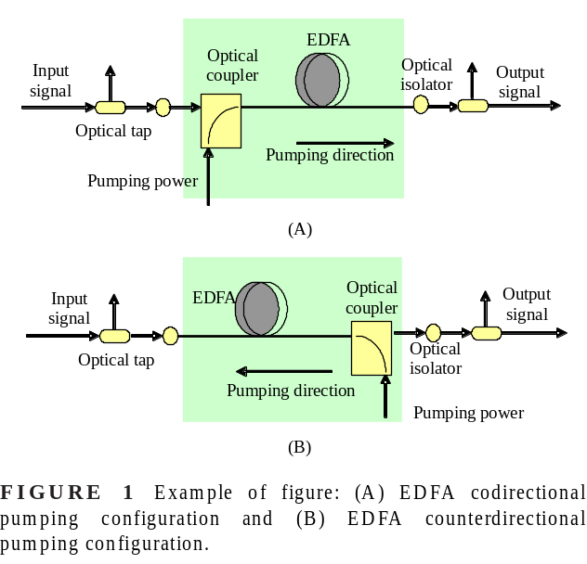will be reworked before publication. Originals of figures should be sharp, be noise-free, and have distinct contrast. High-quality computer-generated illustrations of at least 300 DPI are required. The width of a figure should be approximately 8 cm (3.2 in) or 17 cm (6.5 in). The font size within a figure should be between 6 points and 8 points and must be consistent throughout the figure. The font size within a table should be 8.5 points (see Table 1). The font size of figure captions and table headings should be 8.5 points. Captions and headings must be succinct, and articles (a, an, the) can be omitted. Abbreviations that should otherwise not be used in the paper, such as “vs.,” “i.e.,” and “e.g.,” can be used in figures and tables.
TABLE 1 Simulation parameters for the baseline
Solid  conten | Particle size | Viscosity  (mPa∙s) | Average runtime | Drying temperature
86.7 | 40–100 | 5000–10 000 | 2.0 × 10⁻⁵ | 145/2
86.7 | 40–100 | 5000–10 000 | 2.0 × 10⁻⁵ | 145/2
2.7 | Units and abbreviations
2.7.1 | Units of measurement
ETRI Journal advocates using the International System of Units (SI units). Unit symbols should be used with measured quantities (for example, “1 mm,”) but not without a measured quantity (for example, “a few millimeters”). In other words, if a unit of measurement is strictly part of the text, the full term should be used, whereas the symbol for that unit of measurement should be used when referring to a measured quantity. The following sentence illustrates the difference: “The researchers noticed that a significant change occurred within a few degrees Celsius, that is, between 88°C and 91°C.”

2.7.2 | Abbreviations
A term or name must be presented in full upon first mention, followed by the abbreviation or acronym in parentheses; for example, “discrete Fourier transform (DFT).”
Even if an abbreviation or acronym is introduced in the abstract, it must be introduced in the main body of the article, as these two aspects of the paper are treated separately in this regard.
The abbreviations “i.e.,” “e.g.,” “etc.,” “et al.,” and “vs.” should not be used in the body of the article. Instead, the author should use “that is,” “for example,” “and so on,” “and others,” and “versus,” respectively. However, for brevity, it is acceptable to use these abbreviations in figures and tables.
2.8 | Citations
2.8.1 | Ordering of citations
The order in which works are cited in the text and the order in which these works are listed in the References section must match. In other words, the first work cited in the text must be the first work listed in the references section. Therefore, the first mention of each reference must follow consecutive order. For example, [6] cannot be cited in the text if [1] through [5] have not been cited.
2.8.2 | Form of citations
Each citation should be enclosed in brackets (for example, [1]). For multiple consecutive citations, the first and last should each be enclosed in brackets separated by an en dash, without spaces (for example, [3–7]). For multiple citations that are not consecutive, each citation should be enclosed in brackets and should be separated from one another by a comma (for example, [15,18,23]). If listing both consecutive and non-consecutive citations, the two styles should be used together (for example, [13–26,29,32]).
In the text, the bracketed citation number can be used in lieu of the name(s) of the author(s) of a source, as follows: “As [7] showed, the algorithm performs well.” A sentence should never begin with a bracketed citation number, but should instead be modified with the word “reference,” as follows: “Reference [7] showed that the algorithm performs well.”
2.9 | References
Only material directly related to the author’s investigation should be cited and included in the list of references. All secondary sources used to complete the study must be cited in the References section. The secondary source must be clearly identified, and the author, editor, company, or organization, the title or product name, and the date of publication must be stated.
2.9.1 | Numbering and ordering of references
A numbered list of references must be provided at the end of the paper. The list should be arranged in the order of citation in the text, not in alphabetical order. Only one secondary source should be listed per reference number. Each reference number must be enclosed in brackets. The font size used for the list of references in the References section should be 8.5 points.
2.9.2 | Format of references
The formatting of the References section is a major undertaking and is not to be taken lightly. ETRI Journal provides detailed guidance on its specific stylistic requirements for this section of your paper. Authors are to consult ETRI Journal Author Guidelines for Mathematical Notations and References and ensure that their References section meets the requirements outlined within.
2.10 | Miscellaneous advice
- A zero should be used before a decimal point: “0.25,” not “.25.”
- Instead of using “cc,” the author should use “cm³.” All stated values should be properly labeled: “0.1 cm × 0.2 cm,” not “0.1 × 0.2 cm².”
- Full terms should not be mixed with abbreviations; for example, either “b/s” or “bits per second” should be used, not “bits/s.”
- In the text, a range of values should be stated using the preposition “to” or “through,” not using the symbol “-” or “~”; for example, “Step 1 through Step 4” should be used as opposed to “Step 1 - Step 4.”
- In a figure or table, however, an en dash can be used to represent a range. Note that ETRI Journal refrains from using the tilde (~) because this symbol bears a variety of meanings.
- ETRI Journal follows the rules of American English, not British English. Therefore, a comma or period must be placed inside of quotation marks. The author must pay close attention to the difference between American and British spellings as well; for example, the author should use “color,” not “colour,” and “modeled,” not “modelled.”
2.11 | Errors, revisions, and timeliness
The author is responsible for correcting errors in the manuscript and completing revisions in a timely manner as requested by the editorial office.
ACKNOWLEDGMENTS

REFERENCES
- T. T. Allen, Introduction to discrete event simulation and agent-based modeling: Voting systems, health care, military, and manufacturing, Springer, New York, 2011.
- T. T. Ballen, Introducion to discrete event simulation and agent-based modeling: voting systems, health care, military, and manufacturing, 2 ed., Springer, New York, 2011.
- G. Blanchard and R. Loubere, High-order conservative remapping with a posteriori MOOD stabilization on polygonal meshes, 2015. Available from: http://www.emn.fr/z-info/choco-solver/ [last accessed May 2011]
- R. Boggs, J. Bozman, and R. Perry, Reducing downtime and business loss: adressing business risk with effective technology, Tech. Report Technical report 91-18, InternationalData Corporation (IDC), Sernageomin, 2002.
- S. Elbaum, A. G. Malishevsky, and G. Rothermel, Test case prioritization: A family of empirical studies, IEEE Trans. Softw. Eng. 28 (Feb. 2002), no. 2, 159–182.
- G. Rothermel, A safe efficient regression test selection technique, ACM Trans. Soft. Eng. Methodology 6 (1997), no. 2, 173–210. MR 2000f:91046
- G. Rothermel, M. J. Harrold, C. W. Hirt, A. A. Amsden, and J. L. Cook, A safe efficient regression test selection technique, ACM Trans. Soft. Eng. Methodology 6 (1998), no. 2, 173–210.
- S. Yoo and M. Harman, Pareto efficient multi-objective test case selection, (Proceedings of The International Symposium on Software Testing and Analysis, London, UK), 2007, pp. 140–150.

AUTHOR BIOGRAPHIES

APPENDIX

